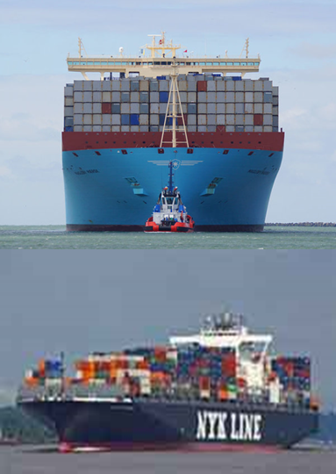
20,000+Maerskiri (?) NYKipleure

Dans le même temps que la compagnie maritime japonaise NYK dépréciait la valeur de sa flotte de près de 25%, elle se voyait contrainte de négocier une fusion avec ses plus féroces concurrents Mitsui O.S.K. Lines and Kawasaki Kisen Kaisha, eux aussi japonais et tout aussi opposés à une fusion. Venant après la banqueroute du sud-coréen Hanjin Shipping Co cette fusion ne se présente pas sous les meilleures auspices et selon Alphaliner 18 des plus grandes compagnies pourraient être conduites à déprécier la valeur de leur flotte de près de 35 milliards de dollars !
Comment alors comprendre l’annonce que Maersk line, qui est aussi déficitaire, pourra accueillir en avril 2017 11 méga porte-conteneurs Triple E dont la capacité passerait de 18300 EVP à plus de 20 000 EVP? Avec un tirant d’eau plus élevé il sera possible d’ajouter un 12ème niveau de conteneurs sur le pont et dépasser ces 20 000 EVP capacité qui semblait encore inaccessible il y a quelques années.

Avec ces annonces, comment allons-nous résoudre le problème de surcapacité ?

chiffre qui pass”erait de lors que les triple E déjà livrés sont limités (!) à 18300 EVP.w much TEU capacity the next generation of Triple E megaships t hat are going to be delivered to Maersk Line are likely to have, breaking the 20,000 TEU barrier for the first time in the industry, as ships continue to get larger and larger, chasing operational cost efficiencies. 11 of the new Triple E's are scheduled to be delivered to Maersk next April. One principal difference from the 18,340 TEU Triple-E predecessors is that the new ships sit deeper in the water and thus enable an extra tier of containers to be stowed on deck, from 11 to 12. When the new generation Triple E's were first announced, Maersk said they would be have a capacity of 19,630 TEU, but this week the analysts at Alphaliner wrote that "First images from the shipyard suggest that Maersk Line has extensively modified the design of the ships to further increase container intake." How much bigger can these ships get? We're not sure, but we have heard designs already exist for 22-23,000 TEU vessels

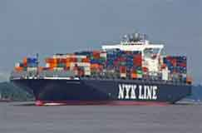
25%That was approximately the amazing write-down on the value of its ship assets that Japanese ocean container carrier NYK Line took a couple of weeks ago in the face of the dismay financial situation the industry is facing. However, that turned out to be right before NYK Line announced a plan to merge with two other Japanese carriers - Mitsui O.S.K. Lines and Kawasaki Kisen Kaisha - fierce rivals that many thought would not join a single alliance (which they did earlier this year) let alone merge. Such is the power of financial turmoil. On the write-down, NYK said that it has "reassessed its outlook for the market from a conservative perspective, and, as a result, deemed it necessary to record an impairment loss as well as a provision for losses related to contracts in connection with its container ships." Not good. All this of course follows the recent bankruptcy of South Korea's Hanjin Shipping Co. NYK may be the first but likely not the only carrier to take such a write down - Alphaliner estimates the top 18 carriers may need to write off some $35 billion of the value of their ships. We hope you've already sold the stock.

